We are a group of Men,
In recognition of this calling
By striving to follow these
Membership Application

Women, Boys, and Girls
we agree to follow the follow-
Rules we individually and

who believe we are called by God to serve as Lay Ministers in one or more of the following areas:
ing Rules of the Order
- To pray each morning and each night.
- To be faithful in the reading and study of Holy Scriptures.

collectively try to live up to the following Objects of our Order

- To promote holy living among
NAME

HOME ADDRESS

CITY, STATE, & ZIP CODE YOUR PHONE
YOUR EMAIL

Acolytes
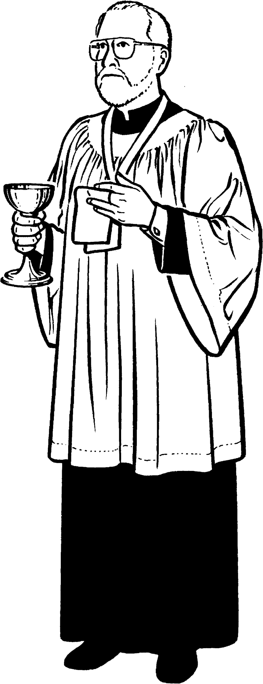
Acolyte Warden and Adult Leaders
  - If physically possible, to be present at the Holy Eucharist every Sun- day and Holy Day.
our members.
DATE OF BIRTH
  - To promote loyalty and full co- PARISH NAME
operation to the clergy and lay

Altar Guild
Bell Ringers Chalicist (L.E.M. 1)
  - To make due preparation before
the service and to say the prayer of the Order.
leaders.
  - To encourage regular attendance
PARISH ADDRESS
CITY, STATE, ZIP CODE PARISH PHONE

Chorister
at the Holy Eucharist, and more

Greeter
Hand Bell Ringers Lay Readers
Lay Eucharistic Ministers (L.E.M. 2)
Lectors SubDeacon Sacristan Usher Verger
È
  - To receive Holy Communion every Sunday and Holy Day if possible and to be duly prepared through self-examination and confession.
  - To render loyalty and cooperation to clergy and to the spiritual lead- ers.
  - To always speak reverently of holy Things.
  - To pray for the order and all her members.
careful preparation for its recep- tion.
  - To promote unity in Christ and friendship and camaraderie among lay ministers.
  - To teach the complete Sacramen- tal Faith as taught in the One, Holy Catholic and Apostolic Church, and promote the prac- tice of the same.
PARISH EMAIL DIOCESE
Having served at least six months,
affirm that I have read and under- stand the Objects and Rule of Life of the Order, and ask to be admitted into that Order and Rule. I solemnly promise Almighty God and the Coun- cil of Governors of the Order that I will faithfully keep the Rule and sup- port the Objects herein printed. I further promise to annually renew my vows and pay my oblation as long as I shall remain an active member of

    - To pray for the unity of the
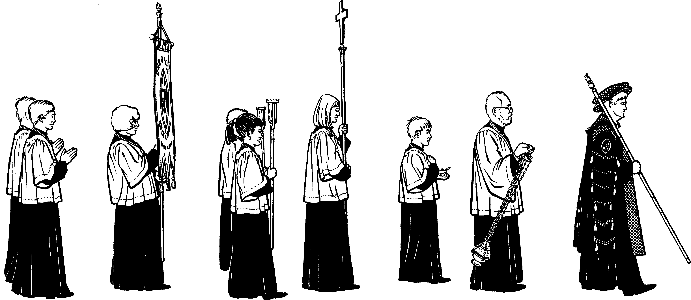
Church.
the Order of Saint Vincent and to no-
tify the Chapter Warden should I de- sire to become inactive, thereby re- linquishing my privilege of member- ship including not wearing the OSV medallion, pins or patches of the Or- der thereafter.

In testimony whereof I hereunto sign my name this day of ,AD 20
X
APPLYING LAY MINISTER

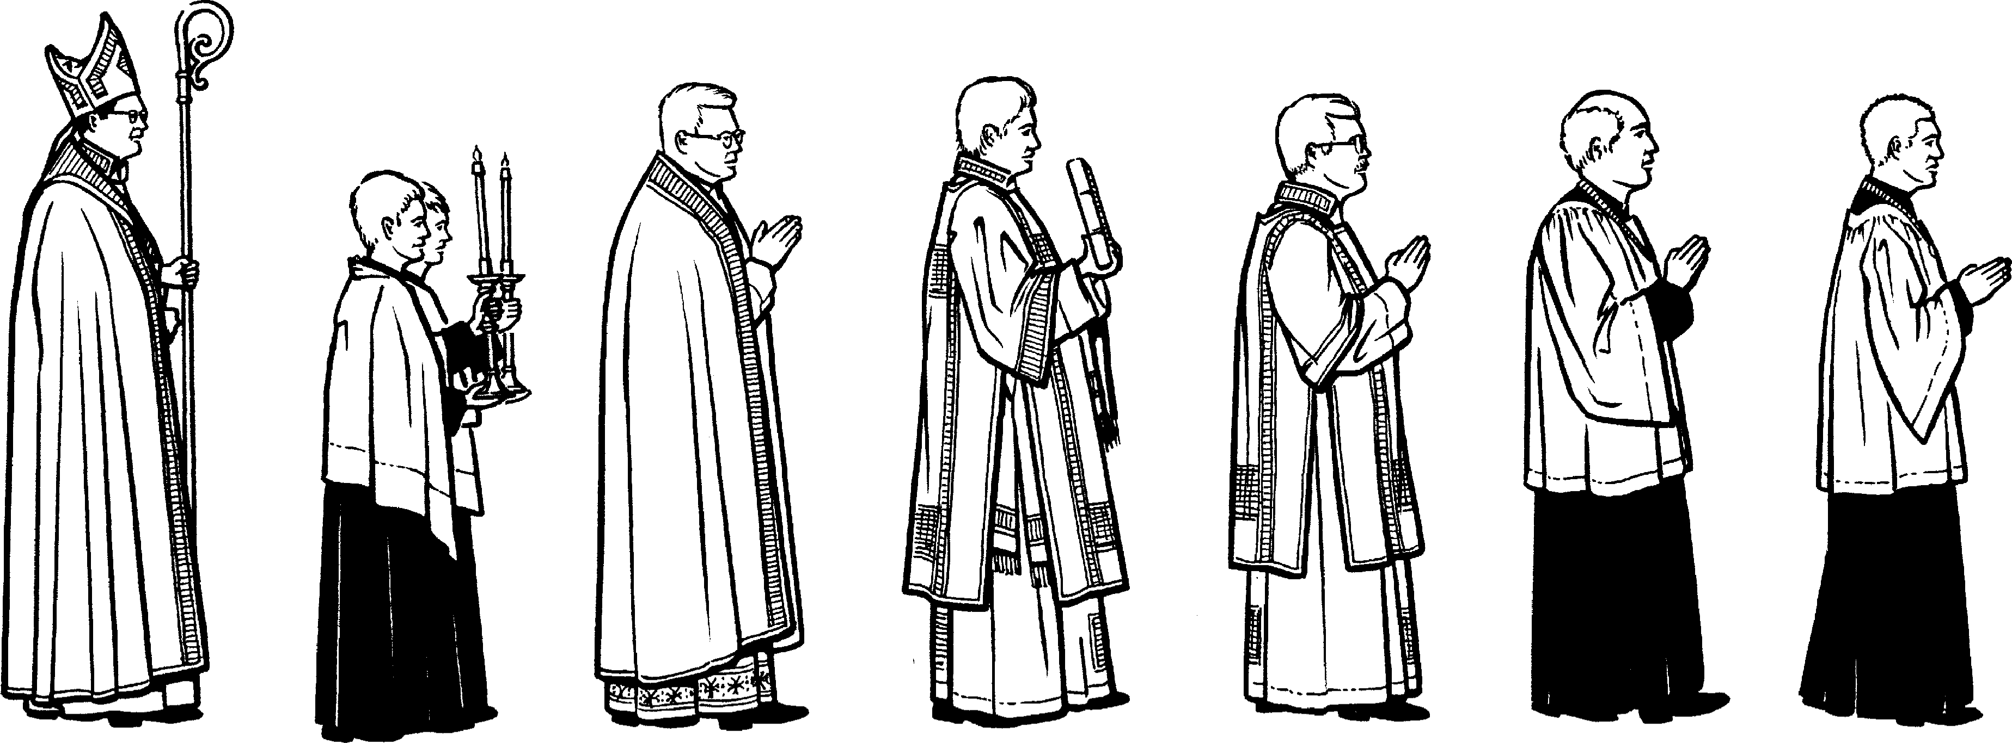
RECTOR’S/VICAR’S WITNESS AND APPROVAL

1 2 3 4

Circle or check one or more of the following ministries as appli- cable:
Acolyte— Adult Chapter Leader — Lector/Lay Reader— Chalice Bearer (L.E.M. 1)— Lay Eucharis tic Minister 2— Usher— Verger— Chorister— Sacristan (Altar Guild)— Greeter— Sub Deacon— Clergy— Other
Initial Application Fee: $20 * Annual Oblation:
Adult Member: $20 Junior Member: $5 Life Member: $150** Clergy or Associate Member: $20***

Notes:
* includes Bronze medallion
** includes gold alloy medallion
*** Does not receive medallion (no initial fee required)
With the approval of the Director General, Chapters may choose to use common medallions for their Junior Members and purchase bronze medallions separately.
With this option no initial fee is required

Please make checks payable to: The Int’l Order of St. Vincent

mail completed application to: The Int’l Order of St. Vincent
P. O. Box 1245 Summerville, SC 29484-1245
USA

These Rules are captured by each member in the de- velopment of our personal Rule of Life which include:
Praying Worshipping Reading Giving

Our Long History and Tradi- tion
Our Order dates back to 1882, when the first Guild of St. Vincent was formed at St. Clement's Church in Philadelphia, where the acolytes joined together in prayer, study, and training as a part of their ser- vice at God's altar. The Order was officially founded on the Feast of Vincent of Saragossa (22 January), 1915 at the Church of the Advent, Boston (which remains our oldest Chapter today) to serve Anglicans/ Episcopalians in all of the North American countries. There, the Pur- pose, Objects, and Rule of Life were adopted by the Council of Gover- nors consisting of clergy and laity with an advising Bishop.
In 1939, the OSV affiliated with the Scottish and British acolyte guilds. This affiliation brought acolytes throughout the Anglican
Communion into fellowship with and prayer for one another.
In 1970, the Order opened member- ship to girls and women, and to all lay ministers involved in sacred ser- vice in 1979. The Governors voted in 1984 to continue affiliation with the newly formed "continuing" Angli- can bodies and to, by word and ex- ample, call all Catholic Commun- ions to visible and comprehensive unity. We are now truly a trans- Catholic order.
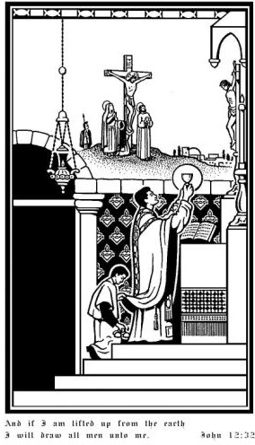
Amori Christi et Ecclesiae
(For the love of Christ and His Church)
For more information about our Order visit our website www.OrderStVincent.org

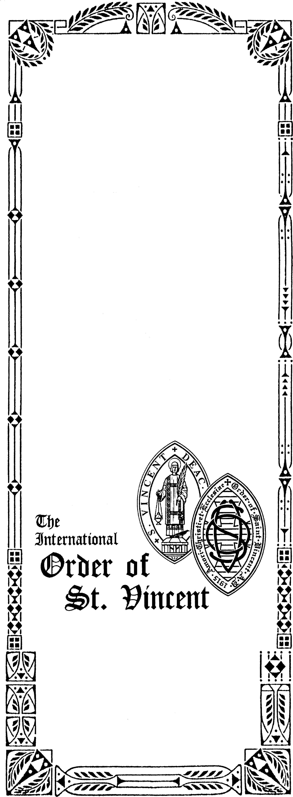5 6
What is
The Order of
St. Vincent?
St. Vincent’s Tract No. 00

© Int. Order of St. Vincent 1999.
All rights reserved. This tract may not be reproduced in whole or in part without the written permission of the OSV.

